A. UPS Response Potential Analysis

A1. UPS and Server Connection Topology
During UPS operation, its real-time energy consumption varies with the load rate. The relationship between UPS energy consumption, energy conversion efficiency, and load rate is shown in Figure 2. The curve in the figure indicates a nonlinear relationship between UPS energy consumption and load rate.
Existing studies have explored the method of using server-level ATS to connect different racks to the same UPS system. This approach allows for the shutdown of some UPS units, thus improving power supply efficiency and reducing SDC energy consumption.
Fig. 1 illustrates the SDC power supply architecture proposed in this paper. The ATS is a compact electrical device with multiple power input ports and a single output port, which is connected to the corresponding server, as shown in Fig. 1 (a). This paper proposes using ATS devices to connect servers to two UPS modules. In this configuration, only one UPS module is in operation, while the other remains in standby mode, as shown in Fig. 1 (b).
(a) ATS structure | (b) UPS Topology Change
- Proposed SDC Power Supply Architecture.
In traditional SDCs, multiple UPS modules are typically connected to a unified intelligent bus system and supply power to servers in different racks through feeders. In this power supply structure, the connection between UPS modules and servers is fixed. Under normal operating conditions, each UPS module generally bears about half of the total server power demand, resulting in a load rate typically lower than 50%, usually ranging from 20% to 35%. According to the UPS energy consumption curve shown in Fig. 2 (a), within this load rate range, the operating efficiency of the UPS modules is approximately 72% to 85%. However, under full-load conditions, the efficiency can exceed 95%. This efficiency difference leads to energy losses of approximately 10% to 23%.
As shown in Fig. 2 (b), the UPS connection topology proposed in this paper effectively addresses the efficiency issue by shutting down one of the UPS (UPS2) when the server load is low. In this configuration, the two server racks are powered by a single UPS (UPS1), with the load rate maintained between 40% and 70%. According to the energy consumption curve shown in Fig. 2 (b), the operational efficiency of UPS1 at this load rate can be improved to 88% to 92%. Moreover, as the number of UPS modules in each UPS room increases and the load rate per unit decreases, the efficiency improvement becomes more significant. This strategy significantly enhances UPS operational efficiency and reduces overall SDC energy consumption, without affecting the normal operation of computing capacity, cooling systems, or other equipment.
(a) Traditional UPS Efficiency Curve | (b) Efficiency Curve of UPS Topology Change
- Relationship Curve Between UPS Efficiency and Load Rate.
The adjustment of the UPS topology does not affect the upward response potential of the SDC, as its goal is to minimize UPS losses under full-load conditions to provide an upward load adjustment. However, this strategy can improve the downward response capability of the SDC in the following two ways: First, the reduction in UPS losses means that under the same load conditions, the power demand of the SDC from the grid decreases. Second, because the energy storage devices and UPS backup batteries within the SDC have limited capacity, lower UPS operating losses allow the energy storage devices to release more energy to the load, thereby enhancing the response speed.

A2. UPS Backup Battery Group Response Model
When a grid failure occurs, the UPS in the SDC must immediately take over the power supply task until the grid is restored or the on-site diesel generator set starts up, ensuring the stable operation of IT equipment. Under normal circumstances, the battery backup system (BBS) must support IT equipment for about 15 minutes, while the diesel generator typically takes approximately 30 seconds to start. Therefore, the UPS only needs to supply power for a short period before the generator starts, resulting in significant redundancy in the operating capacity of the BBS.
To improve resource utilization efficiency, the BBS capacity can be divided into backup capacity and ESS capacity, as shown in Fig. 3. This paper assumes that retaining only one minute of BBS backup capacity is sufficient to ensure continuous operation of IT equipment during a grid failure, while the remaining UPS capacity can serve as dispatchable capacity, equivalent to an ESS participating in load regulation.
- Capacity division of UPS battery.

B. linearization method
The operational efficiency of the UPS exhibits a nonlinear relationship with the load rate. To model this relationship, we use the UPS loss curve and apply a piecewise linearization method, dividing it into L segments. By introducing binary variables β_{i,j,t}, the nonlinear form is transformed into a linear representation:
where, xlow l and xup l represent the range of the l-th segment variable, corresponding to the range of pUPS,out i,j,t. M is a sufficiently large constant, while k_{l} and b_{l} represent the slope and intercept of the piecewise segments. The binary variable β_{i,j,l} determines which segment the UPS loss belongs to.
Since there is no loss when the UPS is turned off, β_{i,j,l} is associated with the UPS's switching state. If the UPS is turned on, the sum of all β_{i,j,l} for the L segments equals 1, ensuring that the loss is assigned to a specific segment. Conversely, if the UPS is turned off, all β_{i,j,l} values are 0, which means pLoss i,j is also 0.
In addition, the SDC typically employs a load balancing strategy, meaning that under the same power source, the power consumption of all operating UPS units is equal. This relationship is expressed as follows:
The linearization result of the PVS topology adjustment is shown as follows:

C. Case Data
The test environment for the cases is an i5 12400f, 2.50GHz six-core desktop, with programming platforms MATLAB 2024a and Python 3.9. The dataset is generated through the Gurobi solver called via the MATLAB platform. The fusion learning bidding model is trained using Pytorch on the Python platform. The congestion management demand response clearing model is solved using the Yalmip framework and Gurobi solver.
- SDC parameters
Parameters | Descriptions | Valus
M | Total number of servers | 100000
pidle i | Server idle energy consumption | 0.1kW
ppeak i | Peak energy consumption of servers | 0.2kW
Tin i,0 | Initial indoor temperature value | 21℃
Tmin i | Minimum allowable indoor temperature | 18℃
Tmax i | Maximum allowable indoor temperature | 24℃
R_{i} | Equivalent thermal resistance | 4℃/MW
C_{i} | Equivalent heat capacity | 0.25MWh/℃
pnetwork i | Network transmission power consumption | 2MW
pother i | Power consumption of other devices | 2MW
CCOP i | Coefficient of cooling | 2
pcool i,max | Power upper limit of refrigeration equipment | 20MW
The maximum allowable delay for LS tasks in the SDC is 0.1 seconds, and the average service rate of servers processing such tasks within the SDC is 20 requests per second. Internet enterprises deploy a single front-end proxy node, and the average arrival rate of interactive requests received during each time cycle is measured in requests per second. For LT tasks, the maximum acceptable processing delay is 24 hours, corresponding to a server service rate of 0.5 requests per second. At midnight, each SDC receives 2×10⁵ LS requests. In addition, the outdoor temperature of both SDCs remains constant at 20 °C throughout all time periods.
The modified PJM five-node system consists of five generators, with inflexible loads connected to Nodes 2, 3, 4, and 5. The GCs of SDC1 are located at Nodes 2 and 4, while those of SDC2 are located at Nodes 3 and 5. The system structure is illustrated in Fig. 1 of the main text. To ensure power-level consistency during dispatch, the power level of the SDC is proportionally increased by a factor of five.
In the IEEE 118-bus large-scale case, the power level of the SDC is not proportionally scaled. The upper limit of power for key transmission lines is set to 190 MW.

D. SDC Bidding Analysis

D1. Analysis of the Single-Period and Single-Node Bidding Model
This section considers a single-node response of the data center during one time period, with a response start time of 9:00 and a response duration of one hour. The other node is assumed to have no power constraints. The bid cost and curves of the SDC under these four scenarios are shown in Fig. 4.
(a) Bid cost curve of the SDC
(b) SDC marginal response bid curve
- SDC's total cost and bid cost curve.
From Fig. 4, it can be observed that considering topology reconfiguration improves the response range of the SDC. However, due to the introduction of non-convex terms in the topology optimization process, the marginal pricing model no longer exhibits monotonicity, and pricing based solely on marginal costs fails to fully account for the cost of topology adjustments. Therefore, the pricing model for SDC participation in DR should not adopt a marginal pricing strategy but rather employ a total-cost-based block pricing approach. A detailed case analysis is provided below.
As shown in Fig. 4 (a), the response ranges of Case 1 and Case 3 are smaller than those of Case 2 and Case 4. This is because when the response power reaches approximately −90 MW and 60 MW, the PVS topology changes, as illustrated in Figure 9, introducing additional BBS and PV power to GC1, thereby enhancing its response range. Compared with Case 1 and Case 2, Cases 3 and 4 exhibit lower response costs within the yellow-shaded range of −65 MW to 0 MW. This occurs because only one UPS unit operates in each UPS room within this range, improving SDC efficiency and reducing response costs.
It is worth noting that UPS topology changes within a single time period do not expand the response range of the SDC. When the SDC reduces its load and the response power drops below −65 MW, the backup battery packs of UPS units previously in standby mode are activated, requiring all UPS systems to operate simultaneously.
- Changes in PVS topology structure.

D2. Analysis of Single Time Period Two Node Bidding Model
Since a conventional unit price quotation model cannot effectively capture the marginal costs of systems containing non-convex elements and lacks the ability to characterize high-dimensional features, this section analyzes the characteristics of the quotation model involving two GCs within a single time period. The bidding cost surfaces for the four cases are illustrated in Fig. 6.
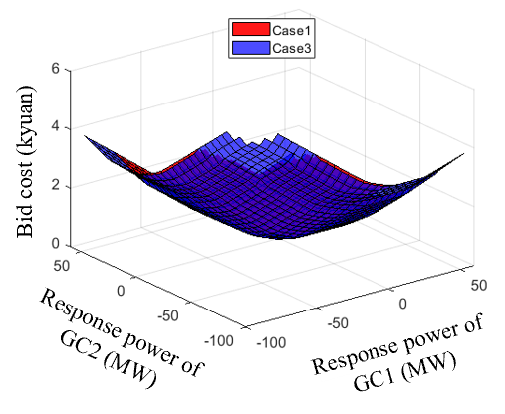  (a) Case 1 and Case 3 bidding surfaces | 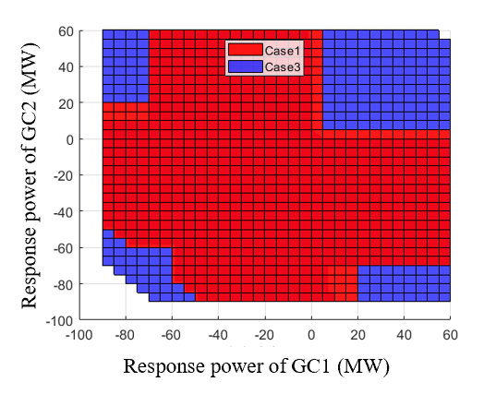  (b) Case 1 and Case 3 bidding surface projection
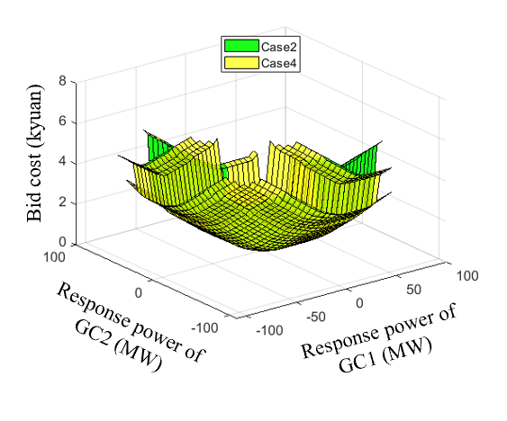  (c) Case 2 and Case 4 bidding surfaces | 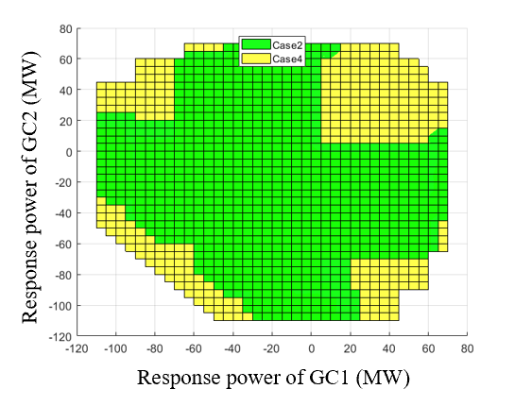  (d) Case 2 and Case 3 bidding surface projection
- Single time period multi node bid surfaces.
By comparing Case 1 and Case 3, it can be observed that the red regions represent higher bidding costs. After considering the UPS topology reconfiguration, the bidding cost is significantly reduced at lower response power levels, which is consistent with the analysis results of the single-period and single-node scenarios. Further comparison between Case 2 and Case 4 shows that incorporating PVS topology adjustments expands the overall response range of the system, while the green regions indicate higher bidding costs.
Comparing the response areas of Case 1 and Case 4 in Figures 2 and 4, it can be seen that the response capability of Case 4 increases by approximately 26%. Therefore, the topology optimization strategy proposed in this study not only effectively expands the system’s response range but also further reduces bidding costs, thereby enhancing the market clearing power level of the system.

D3. Analysis of the Multi-Period and Multi-Node Bidding Model Based on IL
The IL-based block bidding method uses a NN to fit the relationship between the response power and the corresponding cost for the SDC across two GCs and five time periods. The input dimension of the NN is set to 10, with the network structure consisting of two hidden layers, each containing 32 neurons, and the output layer having a dimension of 1. The training results are shown in Fig. 7.
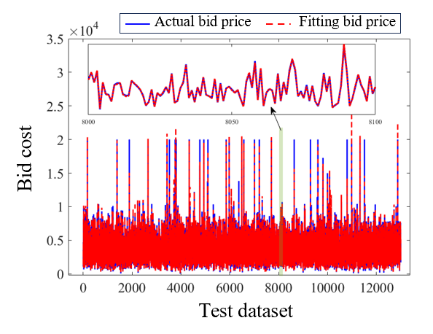 | 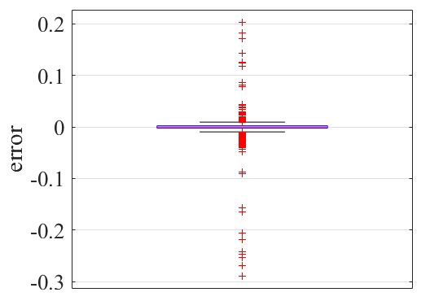
(a) NN fitting curve | (b) Neural network fitting error
- NN training results.
TABLE 2 presents a comparative analysis of the Root Mean Square Error (RMSE), Mean Absolute Percentage Error (MAPE), and Mean Error (ME) of the SDC model on the test dataset. The results indicate that the RMSE of the NN fitting is 0.00859, the MAPE is 1.997%, and the ME is 0.2896. These results verify the effectiveness and accuracy of the constructed NN model in fitting the response power cost.
- Fitting error of NN
Indicators | RMSE | MAPE | ME
Values | 0.00859 | 1.9975% | 0.2896

E. Analysis of IEEE 118-bus system
To verify the applicability of the proposed method in large-scale power systems, simulation studies were conducted on the modified IEEE 118-bus standard test system. The system load, line parameters, and generator cost data were obtained from case118 in the MATPOWER toolbox. The following modifications were made to the original system: six new SDCs were added. The first three SDCs have the same parameters as SDC1 in the PJM five-node system, with their two GCs linked to Nodes 2, 33, and 39, and to Nodes 48, 53, and 83, respectively. The remaining three SDCs share the same parameters as SDC2 in the PJM five-node system, and are connected to Nodes 85, 86, and 101, and to Nodes 103, 115, and 117, respectively. In addition, the 24-hour system load variation is kept consistent with that of the PJM five-node system.
During the scheduling process, Lines 7, 8, and 9 were designated as critical interconnection lines with capacity limits of 400 MW, 600 MW, and 400 MW, respectively. These lines experienced overload during peak-load periods. By introducing SDCs to participate in congestion management, the line flows were effectively regulated, ensuring that transmission power remained within the capacity limits. A comparative analysis was conducted between two scenarios: one with SDC participation in congestion management and the other without. The congestion management costs of the ISO and the revenues obtained by SDCs for providing response services are presented in TABLE 3.
- Clear results of the IEEE 118 bus system.
 | SDC participation in DR costs/subsidy benefits (thousands yuan) | SDC does not participate in DR costs/subsidy benefits (thousands yuan)
MO | 93.53 | 110.46
SDC1 | 0.492 | ---
SDC2 | 0.047 | ---
SDC3 | 0.128 | ---
SDC4 | 0.288 | ---
SDC5 | 0.288 | ---
SDC6 | 1.521 | ---
The results in the table indicate that by involving SDCs in congestion management, the ISO can significantly reduce congestion management costs, while SDCs obtain additional economic benefits by providing response services. These findings further demonstrate the applicability of the proposed pricing model in large-scale node systems.

